THE TITLE OF CONTRIBUTION

Author¹*, Co-Author²
¹ Author address (affiliation, town and country of the author)
² Co-author address (affiliation, town and country of the co-author).
*Corresponding author: e-mail:, Tel.:, complete postal address

Keywords: min. 4 - max. 6,
Abstract
The abstracts are to be submitted in English language. The total length of the abstract should be two pages of B5 size (18.2 cm x 25.7 cm), including figures, tables, acknowledgement and references, if the authors deem it suitable to present these in the abstract. Please do not exceed two pages of B5 (with margins: left 3.0 cm, right 2.0 cm, upper 2.0 cm, lower 2.0 cm, spacing 1) and use a template with pre-defined styles.
The maximum width of the figures is 6.5 cm, with minimal resolution 300 dpi. Photographs should have good quality with magnification markers included on the right of the photograph. The abstract must have 100 words as a minimum.

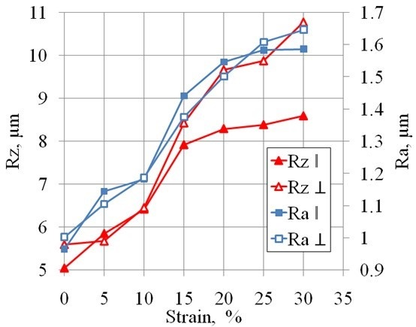
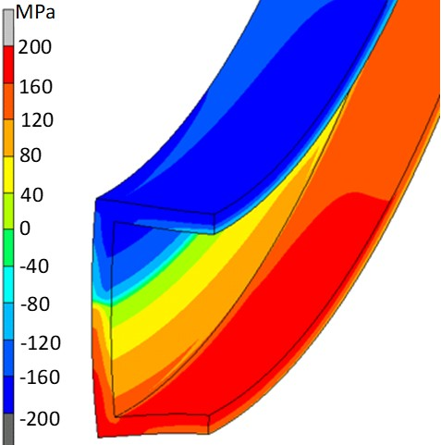

Fig. 1<10 pt Times New Roman bold, align center> Graph xxx <10 pt Times New Roman, align center>

Table 1<10 pt Times New Roman bold, align center>Chemical composition <10 pt Times New Roman, align center>
C [wt.%] | Fe [wt.%] | Cr [wt.%] | Mn [wt.%] | Si [wt.%]
0.10 | 84.6 | 14.5 | 0.5 | 0.3

Acknowledgment: <10 pt Times New Roman bold, align left>
There is a place for acknowledgment <10 pt Times New Roman, align left>

References: <10 pt Times New Roman bold, align left>
- H.R. Wang, W. Wang, J.O Gao: Materials Letters 64 (2010), pp. 219-221.<10 pt Times New Roman, align left>
[2]

